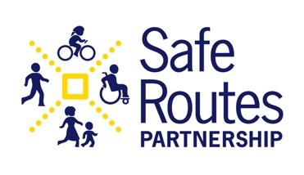
[School Name/Community Organization]
[School Address]
[City, State, ZIP Code]
[Phone Number]
[Email Address]
[Website or Social Media Handles]
Insert your logo here – picture format -> tight

FOR IMMEDIATE RELEASE
[Date]

[School/Community Name] to Celebrate 2024 Ruby Bridges Walk to School

[City, State, Date] — [Community/School Name] is excited to announce its participation in the 2024 Ruby Bridges Walk to School Day. This special event, set to take place on [Event Date], will bring together students, families, and community members to celebrate Ruby Bridges’ courage and promote safe, healthy, and active transportation to school.

Ruby Bridges Walk to School Day is celebrated annually on November 14, the day Ruby Bridges bravely integrated William Frantz Elementary School in New Orleans in 1960. This day honors Ruby’s historic role in advancing civil rights and serves as a reminder of the importance of equality, justice, and education for all children. Communities across the country participate in this event to recognize her courage and to inspire future generations to continue her legacy.

[Insert details about how the community or school plans to celebrate, such as activities, special guests, or additional initiatives tied to the event.]

[“We are thrilled to celebrate Ruby Bridges' legacy while encouraging our students to walk or bike to school safely,”- or similar quote] said [Insert Name/Title of Organizer or Principal].

For more information on how to participate in this event, please contact [Insert Contact Name and Information].

About Ruby Bridges
At just six years old, Ruby Bridges became an icon of the Civil Rights Movement by integrating William Frantz Elementary School in New Orleans on November 14, 1960. Under the protection of U.S. federal marshals, she braved daily opposition and threats as she entered the school, making her a symbol of resilience and the fight for equality in education. Ruby Bridges' story reminds us of the power of one child’s actions to make significant change.

About <<School/Community/Organization Name>>
<<>>
About the Safe Routes Partnership
The Safe Routes Partnership is a national nonprofit organization dedicated to advancing safe walking and bicycling to and from schools and improving the health and well-being of kids of all ages. By partnering with schools, community organizations, and local governments, Safe Routes Partnership aims to create more accessible, equitable, and joyful active transportation options. Learn more at saferoutespartnership.org

For media inquiries, please contact:
[Insert Media Contact Name]
[Insert Phone Number]
[Insert Email Address]
[Community/School Name Website or Social Media Handles]

